Austin Dabney

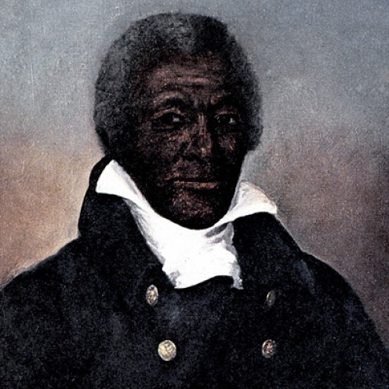
1. Who was he?

2. What was his occupation?

3. Why was he considered a hero?

4. Who was Giles Harris and what did he do to help Austin Dabney?

